Weekly Lab Assignment -2  
Git Stash  
1. Create an file and commit 3 lines.

2. Stash the 4th linea. git stash save "4th line"

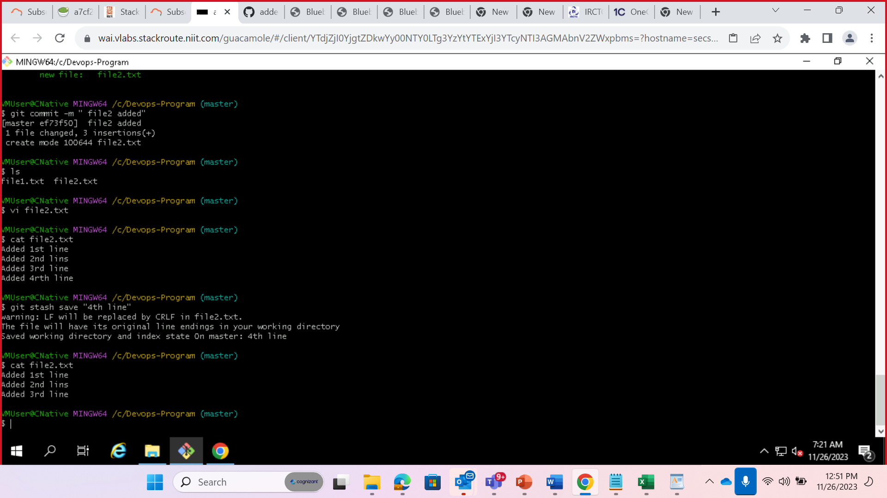  
3. Stash the 5th line separately

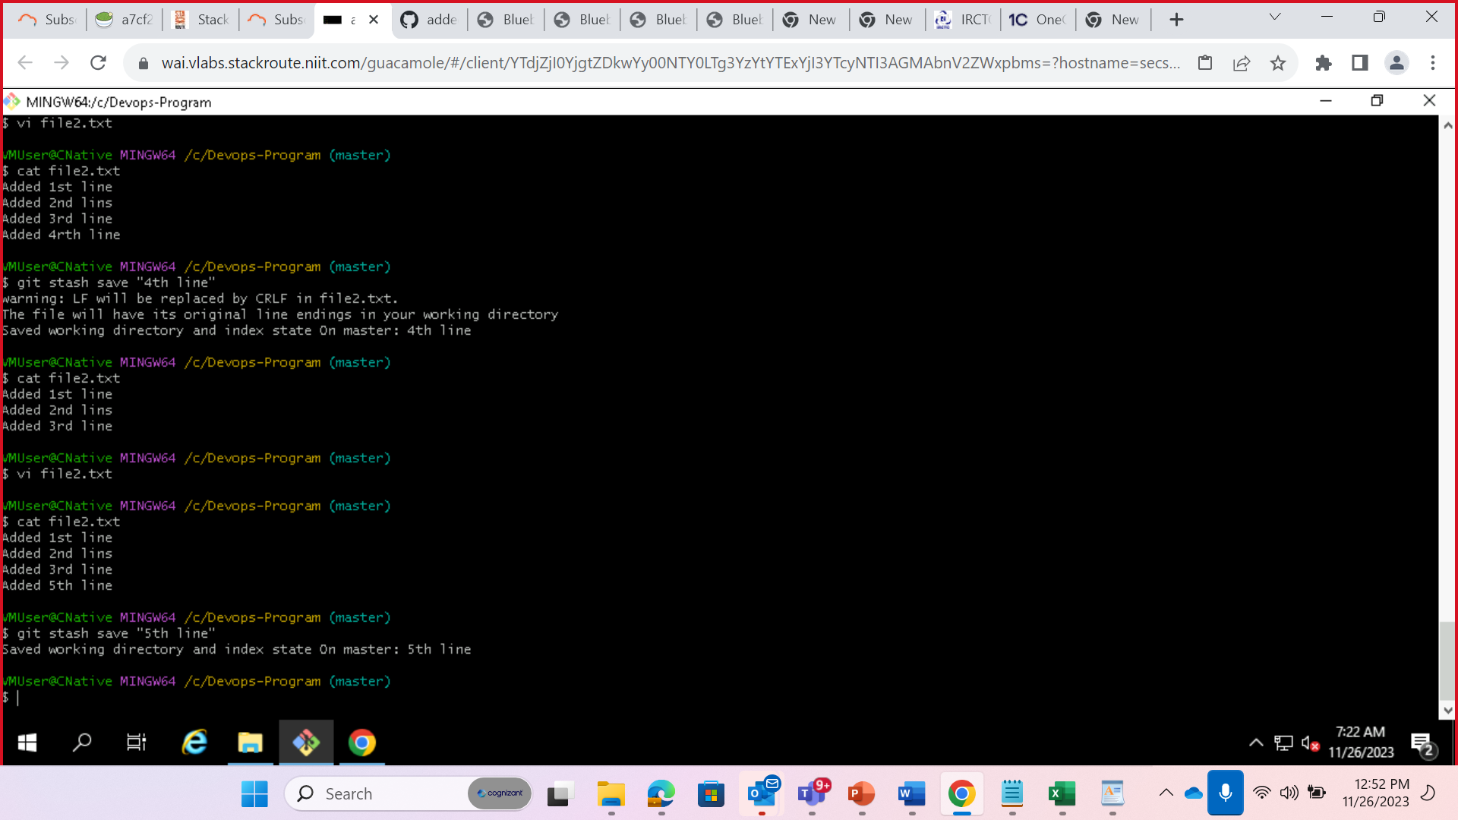  
a. git stash save "4th line"  
4. Add the 6th line to the file and commit.

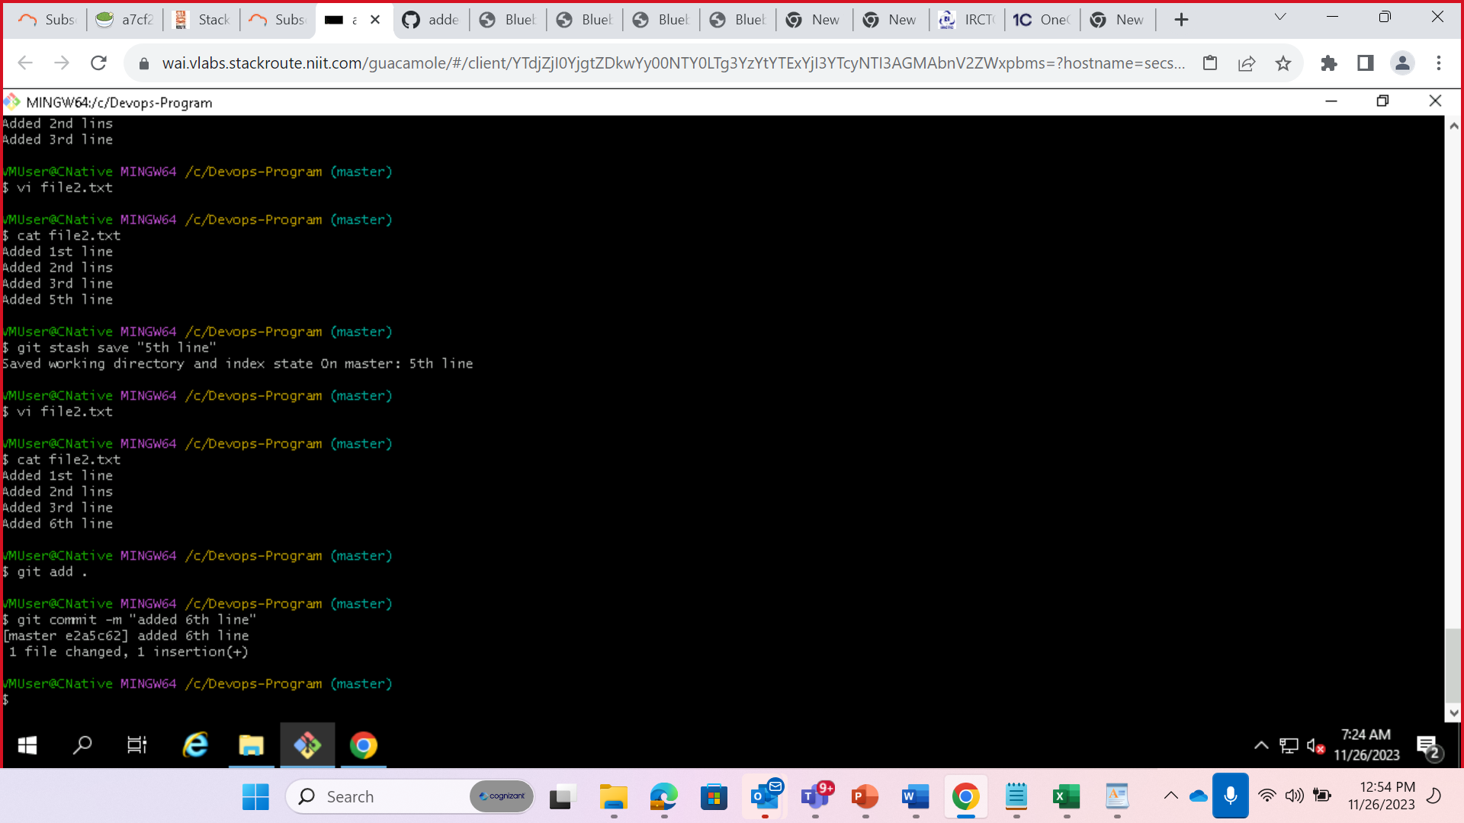  
5. Now add back the 5th line from the stashed area and commit

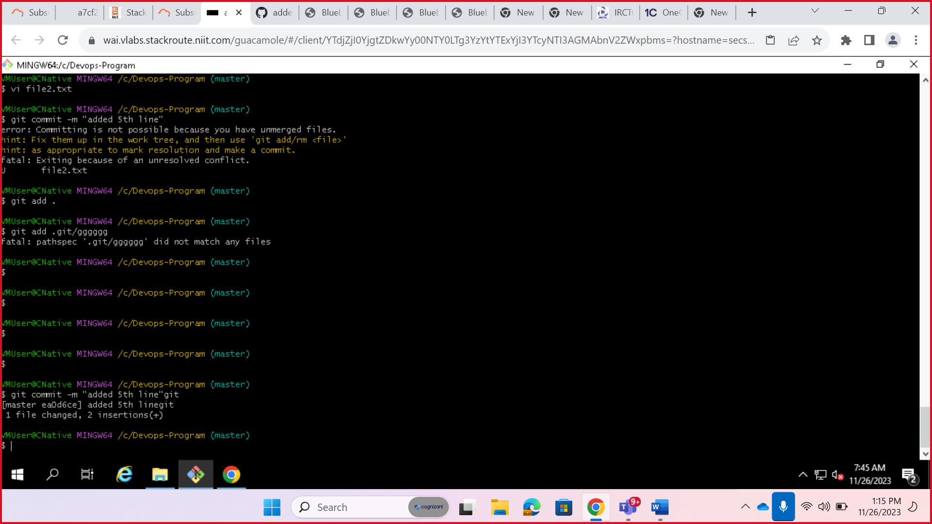

6. Add back the 4th line from the stash and commit, but the stash should remain

